Date: 9/16/24

JRPS Conference Check-In Sheet

Researcher Rey “Dialarmsaw” Banzaert
Advisor Emily “The JRPS Advisor” Naito

What have I accomplished since our last conference?
Impossible - there was no last conference

What did we discuss in our meeting today?
Talked through question language
Looked through collection of sources, discussed what others are needed
Building a robot? - build dog and car?

What will I accomplish by our next conference?
Read the 2 already identified articles (by next Monday)
Start looking for additional sources that fall into the “wanted sources” list
Rey will begin talking to Songbae and parents re: dog motors

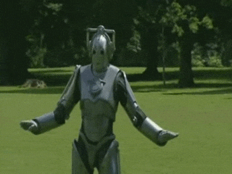
Am I up-to-date on my work?
Yes!

